- The table below provides examples of different sources.
- Use it to help you find and evaluate sources. You can also email library@norwichuni.ac.uk with questions about reliability.

Source Type | Sources | Advantages + | Disadvantages -
Books  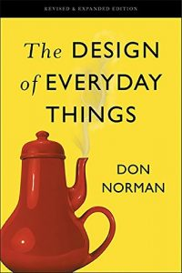 | Examples:  - Discovery toolbar,  - The British Library: www.explore.bl.uk  - Worldcat: www.worldcat.org | - Give a thorough coverage of a topic  - Checked by publisher to ensure quality  - Usually well-researched  - Can include references to other sources | - Take a long time to be published, so information may become out of date  - Author may be biased
Academic Journals  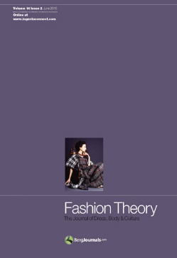 | Examples:  - Art History  - Journal of Visual Arts  - Practice and Fashion Theory. | - Up to date  - Often contain original research  - Short and focused on a specific topic  - Peer reviewed and quality controlled  - Include references to other sources | - Cannot cover a subject in the same depth as a book.
Trade Journals  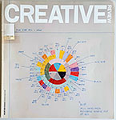 | Examples:  - Creative Review  - Campaign  - Cinefex  - Computer Arts | - Focus on professional interest  - Up-to-date coverage  - Useful source of images  - Highlight new resources  - Chance to engage with professional communities | - Not as extensively quality reviewed as academic journals
Magazines  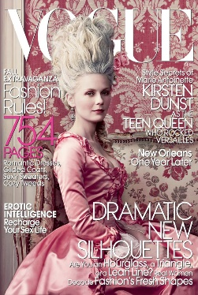 | Examples:  - Vogue,  - i-D,  - POP,  - Oh Comely,  - Tank | - Up-to-date coverage of news and opinion  - Useful source of images | - Can be biased and unreliable  - May be written more as entertainment rather than as factual information
Newspapers  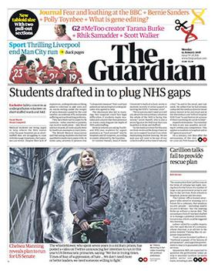 | Examples:  - Broadsheets: The Times, The Independent, The Guardian  - Tabloids: The Sun, The Daily Mirror | - Current source of news and opinions  - Useful source of images  - May include facts and figures  - Broadsheets such as The Times and The Guardian tend to be more reliable | - Can be biased and unreliable  - Political loyalties may influence information  - Tabloids such as The Sun can be written more as entertainment rather than as factual information
Films/Radio/Television Programmes   | Examples:  - BoB,  - Kanopy,  - BBC iPlayer  - Netflix | - Documentaries and recorded interviews can be useful primary sources  - Offer visual representation of subject  - Can be used as a historical documents when based on facts or real events | - May be created for entertainment  - Subjects or events might not be accurately shown; could be biased  - Less likely to offer further references to follow up
Websites   | Examples:  - Gallery & museum websites e.g. V&A  - Practitioner websites  - Organisational websites | - Information can be found quickly  - Can be easily updated  - Gallery websites provide information about a piece (medium, size, date of creation) | - No quality control; anyone can upload information.  - May not be of an academic standard  - May be unreliable or misleading  - Hard to narrow down useful results
Statistics  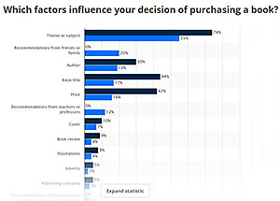 | Examples:  - Statista.com  - Office for National Statistics, Data.gov.uk | - Can provide quantitative data (numbers) to support an argument | - Statistics could be manipulated

